Answer Sheet!
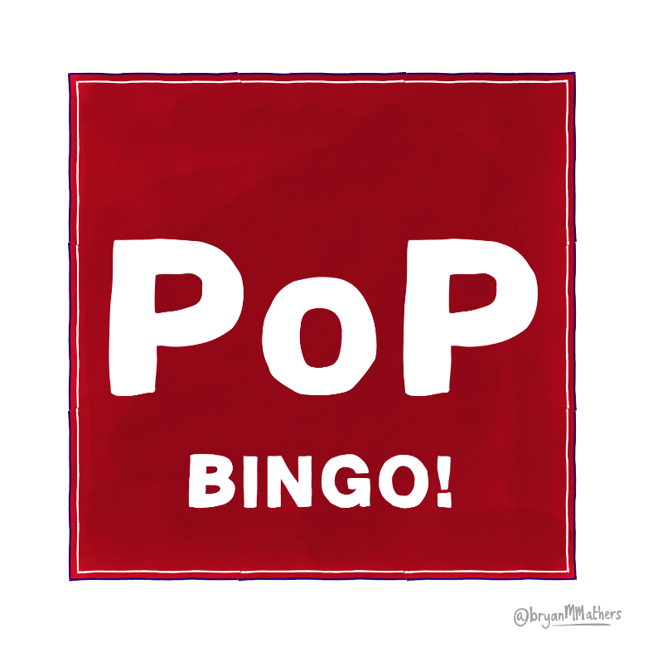
No | 70% | Your age | 39% | To further your career
Facebook | 0% | A glass of alcohol | A good quality head shot | Your hobbies
Yearly | No, it’s never a good idea |  | LinkedIn | To find a date
Your friends | Yes | Yes, if they have upset me | Yes, if it’s from my private account | It never needs updating
Every time I achieve  something new | WhatsApp | I'm really bad at grammar | Your expertise | There is no purpose

