Answer Sheet!
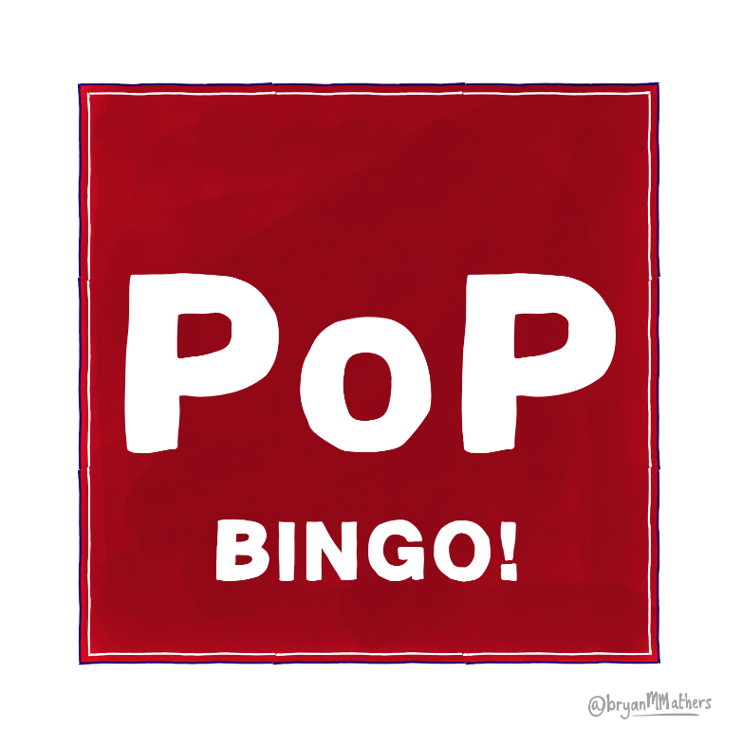
Your expertise | No | Your age | 39% | To further your career
Facebook | Yes | A glass of alcohol | A good quality head shot | Your hobbies
Every time I achieve  something new | No, it’s never a good idea |  | Yes, if it’s from my private account | To find a date
Your friends | Yearly | Yes, if they have upset me | LinkedIn | It never needs updating
0% | WhatsApp | I'm really bad at grammar | There is no purpose | 70%

