Answer Sheet!
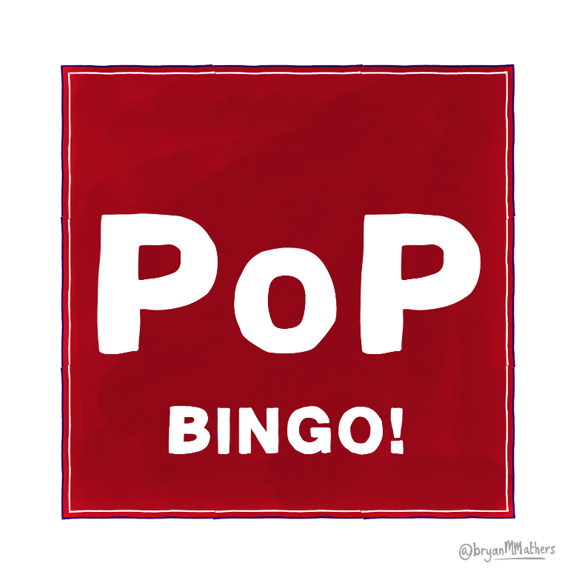
39% | No | Your age | 70% | To further your career
Facebook | 0% | A glass of alcohol | A good quality head shot | Your hobbies
There is no purpose | Yes, if it’s from my private account |  | LinkedIn | To find a date
Your friends | Yearly | Yes, if they have upset me | No, it’s never a good idea | It never needs updating
Every time I achieve  something new | WhatsApp | I'm really bad at grammar | Your expertise | Yes

